Bowie National LLC. Storm Events

Jediniah Womack

Bowie State University

**Introduction:**

Global warming has a huge affect on storms and global warming is continuously rising causing extreme changes to the environment. In this paper I will be explaining the impact of storm events on specific states and the damage from the type of storm event. In the data, there will be five states which are Texas, Florida, North Carolina, Louisiana and California. We picked these states because they have the most data for the types of storm events. The type of storm event data I have is tornados, hurricanes, wildfires. The problem is that storm events are affecting costs of damage. The purpose of this report is to get data from these storm events to figure out a solution for our company to help with the costs of property damage. Below is the concept map.

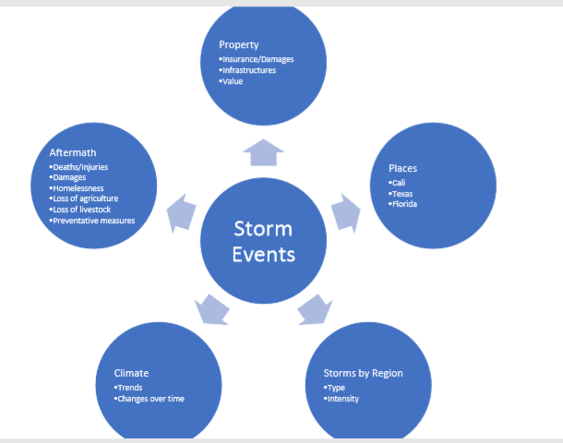

Our company has four questions for our research. First, what was the frequency of hurricanes, floods, tornados and wildfires? Another is what was the total property damage for these states? Also, what is the total cost of claims paid out? Lastly, how many fatalities occurred in these states? In the concept map we wanted to decide what places to use that had the most frequent storm events in the U.S. In our data that will be shown later in the discussion explains why we used these four states. The number of hurricanes, floods, tornados and wildfires was very high in these areas. Also, using data from NOAA, it showed there was a frequency of those type of storm events in those states. We included property damage because how big of a part it plays on the damage of the storm. Insurance can be extremely expensive for a house that has been destroyed and you need to know the cost to rebuild it. The total value is very important because it explains exactly how much the insurance will cover and how much you will need to pay. For the total cost of claims paid out question we wanted to know just exactly how much money was paid for people that had destroyed property damage and who needs more help. We then can assist by knowing how much each person’s property damage costs, to see if they need more assistance. Lastly, we wanted to know the storms by region and the aftermath of storms. We used Storms by region to tell us the intensity and strength of the storm event and damage it caused. The more intensity that the storm has the more property and agricultural damage that occurred. The aftermath of the storms tells us exactly how many fatalities each of the four states from the storm event were.

**Getting the data:**

For our data set we used the NOAA data from years 2001 – 2011. We did this because we wanted to use a ten-year comparison of storm events from this time and see if there was any consistency in the number of damages to property. The variables we used was year, month and state. We used Florida because it has a high number of hurricanes and floods. Texas also has a high number of hurricanes and floods that affect the state. Oklahoma has a lot of tornados in the data that was shown, so we decided to use this state. California, we saw that they have many wildfires which causes a lot of property damage. We used direct injuries and direct deaths as our variables to see the number of injuries and deaths caused by the storm event in that state and time. There were few indirect injuries or deaths in the data, so we decided not to put that in the data set. Some more variables we used were damage property and damaged crops. This is huge for our data set because it tells us the exact number for costs of damage to property and crops in that area. Also, we used source variable and magnitude, source told us where it was coming from and magnitude told us how strong the storm event was. The stronger the magnitude showed us the brutality and damage of some storm events. There were some data conversions that we changed throughout the process of our data. We decided to change the states, we were first going to do New York, Alabama, and Mississippi, along with the rest of the other states. Also, for the data we were going to do data from years 2000 – 2018. But we changed that to 2001 – 2011 to crunch the data that we wanted to focus on.

**Results and Insights:**

We wanted to know the total property damage for each state. Florida had the highest tornado damage out of the rest of the states. California had the least number of tornado damage as you can see in the visualization below. But for wildfire, California had the highest amount of property damage which is way higher than any other state. Louisiana had the lowest with a little over 100,000 dollars in property damage. For hurricanes, Florida has the most property damage from 2001 – 2011. But Louisiana is right below that with 5 billion less than Florida. The power of hurricanes is extremely strong in these areas of the south causing a lot more property damage. Lastly, California has the highest property damage in floods. Florida is the second highest in property damage for floods; while Louisiana has the lowest amount. Property damage can be very expensive, but you must be prepared for heavy storms and occurrences. Knowing the area, you live in and the position of where you are at is important if you are concerned for the cost of your property.

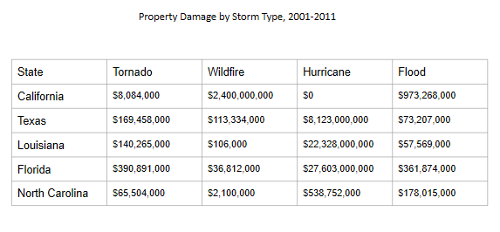

We wanted to know what the frequency of storm events in different states was. Also, to see which states has the most common type of storm events in the area during 2001 – 2011. In the data we learned that tornados were most common in Texas with 1,522 of them from the ten-year span. California having the least of tornados over the ten-year span. Texas is in tornado alley which is an extremely frequent spot for tornados. California had the greatest number of wildfires with 705 of them. That is a high number of wildfires compared to the rest of the other states. Texas has the second highest number of wildfires with 91 of them, but it does not get any close to California. Louisiana has the highest number of hurricanes with 195. That is a high number of hurricanes because of how powerful of storms they are and the damage that they cause. Florida has the second highest number of hurricanes with 164, which is also a high number of hurricanes. Both states are in the south, which is another reason they get hit with hurricanes consistently. Texas has the lowest number of hurricanes with 59 that it gets hit with and California does not get any hurricanes. But as you can see in the visualization below California and Texas has the highest number of wildfire and tornado. Florida and Louisiana has the highest number of hurricanes in the data set. The frequency of storms tells us which area gets the most of that type of storm event and why you should worry about that area. Knowing what storm event occurs most in that area will help keep you safe and have knowledge of what storms you should be aware of.

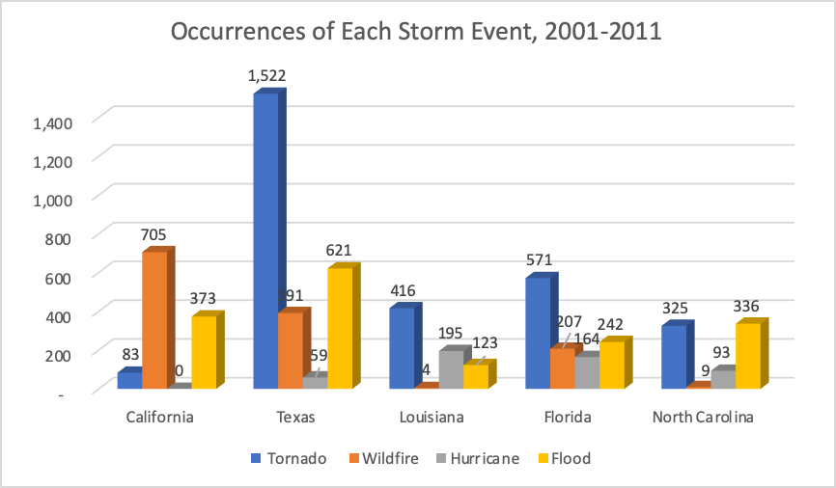

For our data report we wanted to know how many deaths or fatalities occurred between 2001 – 2011 because of storm events. We wanted to know what direct deaths were caused by storms during the ten-year span. Deaths from a storm also tell us if it was powerful enough to cause death to people. In the data we found out that Louisiana has the highest number of deaths over the ten years. There were 831 deaths combined over the years in one state. This amount is skyrocketing over the rest of the states. Louisiana has this high number of deaths because of hurricane Katrina that hit the state in 2005. When the storm made landfall, it had a Category 3 rating on the hurricane Scale. But when it hit Louisiana it was a category 5 hurricane which is why it was so powerful. It had winds of 100–140 miles per hour and stretched some 400 miles across. The storm itself did a great deal of damage, but the aftermath of the storm was catastrophic. In the “Hurricane Katrina: Facts, Damage, & Aftermath” article by Zimmerman he says, “Katrina was the most destructive storm to strike the United States and the costliest storm in U.S. history, It ranks sixth overall in strength of recorded Atlantic hurricanes.” At the time people were not as aware of hurricanes as they are in modern times. So, in this case many people stayed at their homes in Louisiana and lost their lives. Florida came in second with the number of deaths having 70 of them. Yet this is extremely lower than Louisiana there are still some deaths in this state. Texas and California have the lowest with 35 deaths.

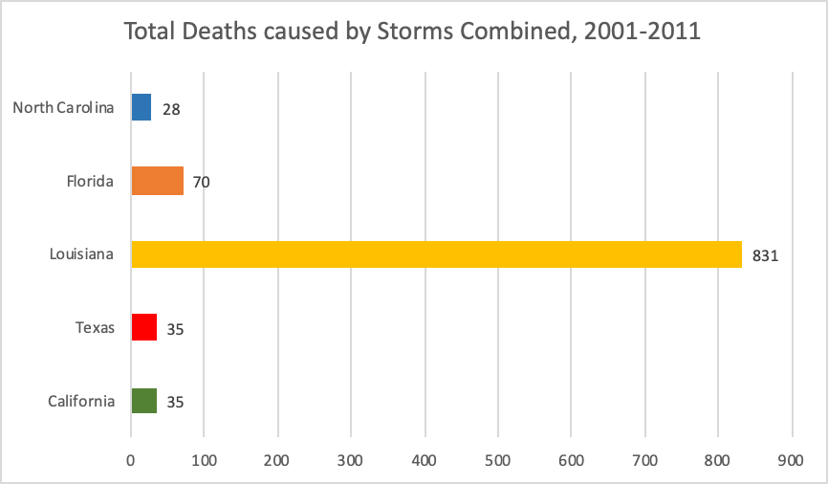

We wanted to figure out the total cost of claims paid out from 2001 – 2011. We used a Fema data set to figure out the dollar amount of claims made and paid out. Insurance coverage is what helps people able to pay off property damage and we as a company can help figure that out. Getting data from the NOAA data set we found out that in 2005, there was 17,770,443 claims that was paid out. Of course, this was because of Katrina the claims were so high in this year. It is an outlier in 2005 from the data from 2001 – 2011. All of the other years were consistent in the number of claims paid out, spanning from a couple million apart and a couple hundred thousand.

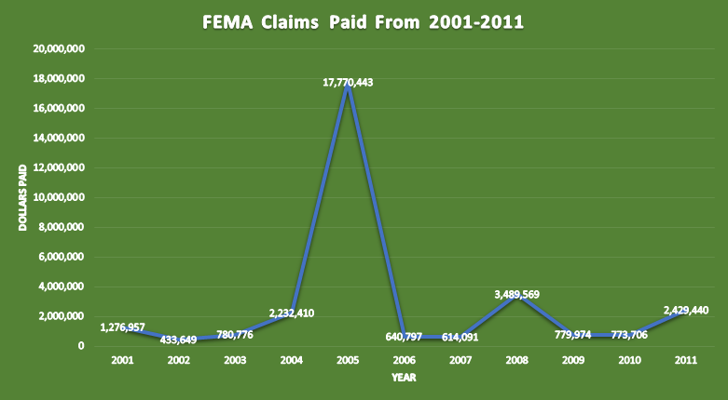

Some recommendations I have is that we as a group could have work better with communicating from the start. We ran into a conflict at the end because of what we wanted to have and get done. Personally, for me I recommend spending more time on the data and organizing it better. I did not know that the process of researching data is so time consuming. Fema data helps with insurance claims and the NOAA data set was extremely helpful. The filter works well for organizing data, next time I will better use my resources for my work. After checking the results of these visualizations, it shows the data that we collected answers the questions for our report. It was not easy putting the data together, but once we did, we were set to go. After having careful research, we intend to keep Bowie National LLC. the same. The data that is there is correct and valuable to use. We prove and show that it is reliable to use for company.

**Discussion:**

The impact of storms is extremely important to the environment. They can affect costs of damage to property. We did this report to figure out the frequency of storm events in states. Also, we figured out what the total property damage and the total cost of claims paid out. The amount of fatalities we figured out for the total amount of each state. The data we learned let us answer the questions we were trying to figure out. Data science is not easy but once you figure out your data and info it comes together in place. It was new working with people I do not know but it also helped because it taught me to communicate to come to a solution with people who had different ideas. In our group everyone had their own skills and ideas but after we communicated and worked together, we were able to come to a solution. I enjoyed my experience for this report and team presentation. I will take this experience with me in the future. If I could get the chance, I would like to experience a project setting like this again but to better prepared as I am now.

**References:**

<https://www.ncdc.noaa.gov/stormevents/>

<https://nca2014.globalchange.gov/>

<https://www.weather.gov/mob/events>

Wright, Pam, (2018). ‘Florida Hammered by Severe storms, Tornados: Dozens of homes damaged’ Weather.

Zimmermann, Kim Ann, (2015). ‘Hurricane Katrina: Facts, Damage & Aftermath’, Live Science Contributer.